JOB DESCRIPTION

Official Job Title: | Programme Specialist- Adolescents & Youth Development and Gender Mainstreaming  Duty Station: Pretoria, South Africa
Grade (Classified) | NO-C
Post Number: | 22532
Post Type: | ☐ Rotational ☒ Non-Rotational
Classification Authority: |  | Date: February 2018

1. Organizational Location

Under the overall guidance of the UNFPA Representative, the Programme Specialist- Adolescents and Youth Development and Gender Mainstreaming is located in the South African Country Office (CO) and reports to the Assistant Representative.

2. Job Purpose

The Programme Specialist, Adolescents and Youth Development and Gender Mainstreaming, provides high level programme and technical support for country programming on Adolescent and youth development and Gender mainstreaming. This includes ensuring effective management of UNFPA supported activities in the areas of Adolescents and Youth health and Gender Mainstreaming. S/he oversees programme planning, implementation, monitoring and evaluation, joint programming initiatives in the support of government priorities, while working in an integrated and collaborative manner with the Country Office’s programme and operations staff.

3. Major Activities/Expected Results

Under the overall guidance of the Representative and direct supervision of the Assistant Representative, the incumbent performs the following:

- In collaboration with Government counterparts, NGOs and other partners, the programme specialist provides substantive leadership and inputs into the design, implementation, monitoring and evaluation of adolescents and youth and Gender Mainstreaming programme taking into account socio-economic cultural, and other structural factors in line with government priorities and according to UNFPA policies and procedures;

- Oversees achievement of adolescents and youth development and gender mainstreaming sub-programme results by ensuring appropriate policies and procedures are applied and appropriate monitoring and oversight mechanisms and systems are established and implemented. This includes but is not limited to: development of work plans, initiating and monitoring activity implementation (as appropriate), monitoring programme budgets, disbursements and expenditures, and assuring both narrative and financial reporting by both Implementing Partners and UNFPA country office;

- Guides the development and implementation of national policies and strategies for adolescents and youth health and gender mainstreaming (especially Prevention of HIV prevention, other STIs, Teenage pregnancy and Gender- Based Violence) through support to national departments and technical working groups in the relevant technical areas;

- Reviews the political, social and economic environment relevant to adolescents and youth health & development and gender-based violence prevention and pursues opportunities for UNFPA assistance and intervention;

- Assesses implication of new policy developments and strategies on programme execution and ensures appropriate implementation;

- Identifies initiates and coordinates gender collaborative partnerships on Adolescents and Youth Development and Gender Mainstreaming with potential implementing partners, experts, government counterparts other UN agencies and CSOs;

- Provides substantive input into advocacy strategies taking into account local political and social context. Advocates and advances UNFPA’s policy agenda by participating in strategic advocacy platforms and public information events in support of the country office’s advocacy and policy efforts on scaling up evidence-based models in support of Adolescents and Youth Development and Gender Mainstreaming;

- Provides programmatic and technical assistance to the adolescents and youth development and gender mainstreaming through support to implementing partners, consultants, and UNFPA Country Office teams;

- Supports the collection and sharing (including through operational research) of lessons learnt and best practices that enhance the effectiveness of Adolescent and youth development and Gender mainstreaming interventions. Disseminates them to stakeholders, and advocates, mobilizes and convenes partners for large-scale up of response to challenges facing adolescents and youth, with a gender lens;

- Continuously analyzes population dynamics as well as Sexual and Reproductive Health data with specific emphasis on Adolescent and youth development and Gender mainstreaming and uses data to influence national policy, provincial and district programmes and programmes supported by UNFPA and other partners;

- Represents UNFPA in the inter-agency forums, including the UN Gender Theme Group for overall coordination and facilitation of joint UN work on Gender mainstreaming ;

- Support UNFPA Representative to dialogue and lobby with major funding organizations and development partners to leverage funding for adolescents and youth and gender mainstreaming programming. Actively participates in resource mobilization efforts of the Country Office by ensuring identification of potential funding sources, donor profiling, preparation of funding concept notes, proposals, donor reports and participating in related donor/potential donor meetings;

- In liaison with the communications, advocacy and partnerships programme analyst, and other relevant programme staff, prepares relevant thematic background documentation, i.e. programme summaries, briefing notes, talking points, speeches and other communication materials as necessary; and

- Performs any other duties as directed by the Representative/ and other management team members to ensure the success of the country programme.

4. Work Relations

The Programme Specialist - Adolescents and Youth Development and Gender Mainstreaming oversees the work of the relevant consultants and experts and establishes and maintains collaborative relationships with counterparts in government, multi-lateral and bilateral donor agencies, private sector and civil society to address emerging issues. S/he must effectively influence counterparts from diverse backgrounds to contribute to achieving UNFPA’s mandate in Sexual and Reproductive Health (including adolescents and youth health and development and gender mainstreaming).

The position holder is located within Sexual and Reproductive Health team, and works closely work with the other Country Office staff. Other internal contacts include relevant staff at the Regional Office, Technical Division, Programme and counterparts in other country offices.
External contacts include programme Implementing Partners, UN agencies in country, and counterparts and partners in country programme activities, including national and international NGOs, independent experts etc.

5. Job Requirements

Education:
Master’s degree in Public health, Medicine, or social sciences such as Gender and Development Studies

Knowledge and Experience:

- 5-8 years professional experience preferably in programme management in the public, NGO or private sector, 4 of which should have been in the area of Adolescents and Youth Health and Development and Gender Mainstreaming.
- Experience working in collaboration with government, development partners, civil society organizations and private sector.
- Excellent technical drafting and report/proposal writing and presentation and interpersonal communication skills
- Proven ability to effectively collaborate with team members to achieve demonstrable results.
- Demonstrable capability to cultivate strategic partnerships and to maintain political relations for programme development.
- Proficiency in computer skills, particularly in current office software applications

Required Competencies:

Core Competencies: See the Diagram Below

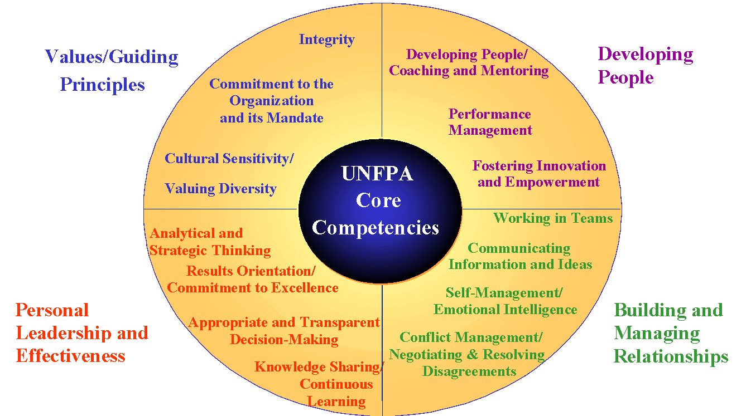

Functional Competencies:

- Advocacy/advancing a policy oriented agenda – influencing the public policy agenda; demonstrates political/cultural acumen in proposing technically sound, evidence-based approaches and solutions;

- Results based programme development and management – achieving results through programme design and innovative resourcing strategies; ensures integration of UNFPA’s strategic concerns in inter-agency, other multilateral initiatives and multi-sectoral development frameworks;

- Leveraging the resources of partners/ building strategic alliances and partnerships – building strategic alliances; makes effective use of UNFPA’s resources and comparative advantage to strengthen alliances;

- Innovation and marketing of new approaches – fostering innovation in others; creates an environment that fosters innovation and innovative thinking;

- Job knowledge/technical expertise – expert knowledge of own discipline; possesses expert knowledge of advanced concepts in primary discipline, a broad knowledge of related disciplines, as well as in-depth knowledge of relevant organizational policies and procedures.

Languages:

Fluency in English.

6. Signatures/Certification:

Incumbent’s Name & Signature  (If Applicable) | Date
Immediate Supervisor’s Name & Signature | Date
Division Director’s Name & Signature | Date

