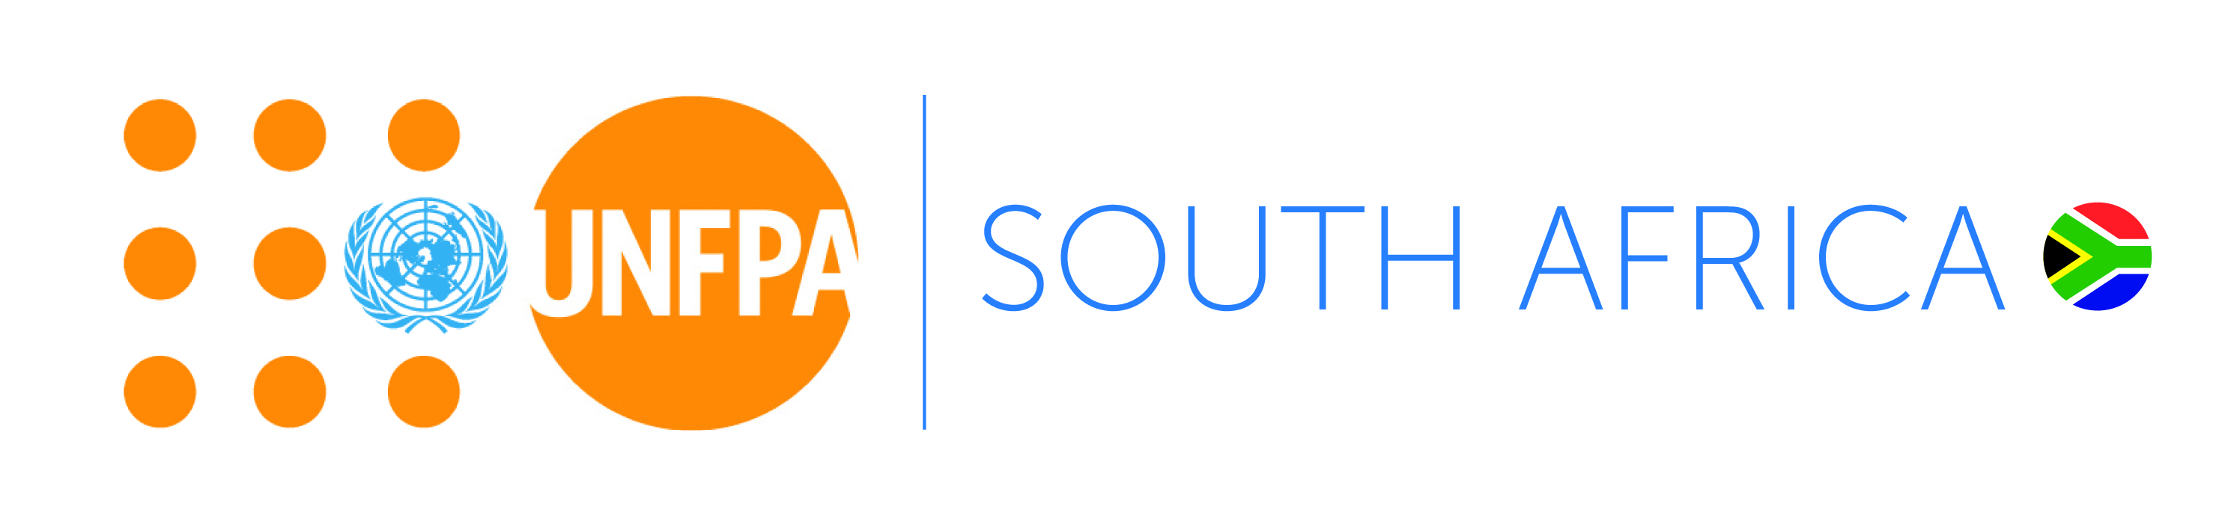
Terms of Reference

UNFPA Youth Advisory Panel 2018- 2020

Introduction
Adolescents and youth are a priority in UNFPA’s mandate and in all advocacy efforts and programmes worldwide. In South Africa, 41% of the South African population is made up of young people between the ages of 14 and 35 years. The South African National Youth Policy places a commitment towards prioritising the needs of young people with respect to education, health and well-being, economic participation and social cohesion.

Over the years UNFPA has worked in close collaboration with other UN agencies, government, Non-Governmental Organizations (NGOs), including youth in mobilizing global commitment to respond to young people’s realities and needs in the area of Sexual and Reproductive Health. UNFPA’s Strategic plan recognizes that young people’s health, education, skills-building and overall development are of utmost global urgency for sustained socio-economic development. Investing in young people’s development is the most strategic (and cost-effective) intervention for achieving all the global development goals. Young people’s human rights, security and well-being are central tenets in ensuring that their present as well as their future life becomes productive and fulfilling.

UNFPA Country Office in Pretoria is therefore seeking 15 Youth Advisory Panel (YAP) members to allow young people the opportunity to lead and advocate for their own development, strengthen young people's leadership and meaningful engagement with government, UN Agencies, NGOs and all other developmental stakeholders especially on issues concerning them.

The Youth Advisory Panel

In 2013, UNFPA established a Youth Advisory Panel (YAP) to actualise our commitment to empower young people to participate in decisions that affect their lives, express their views and opinions in accordance with basic human rights principles and the Convention on the Rights of the Child. The YAP gives young people a voice and helps to guide UNFPA’s priority-setting in this core area of our mandate and involves young people and youth-serving organizations in advising UNFPA in the design of youth-friendly policies and programmes from a results-based perspective. The YAP demonstrates a shift away from working for young people, to working in partnership with young people to ensure youth-friendly approaches and action.

In 2015 UNFPA expanded the national YAP by establishing provincial Youth Advisory Panels in Kwa- Zulu Natal and Eastern Cape, provinces where UNFPA supports government programme implementation. The priority districts in the Eastern Cape are OR Tambo and Alfred Nzo and in Kwa- Zulu Natal it is uThukela district.

Purpose of the Youth Advisory Panel

To establish a mechanism for open dialogue and exchange between UNFPA, UN Agencies, government and youth groups and youth-serving groups and to advise UNFPA and all other developmental stakeholders on the strategic opportunities and actions to address adolescent and youth issues within the organizational mandate.

Specifically, the objectives of the Panel are to:
- Facilitate the exchange of information and knowledge-sharing about best practices and lessons learned from youth policies and programmes as well as on major opportunities and challenges for moving the youth development agenda forward including gender equality and sexual and reproductive health and rights;
- Represent the voices of youth, advocate for and facilitate the meaningful engagement of young people by various youth development role players in policy and programme development forums;
- Enable greater understanding among UNFPA, government, youth groups and youth-serving partners on UNFPA’s policies and programmes, and how adolescent and youth concerns can be more effectively addressed in various political and socio-cultural contexts;
- Advise UNFPA and its partners and government on how to ensure youth participation in the development of its policies, programmes and activities across the areas of its mandate;
- Participate and engage in the UNFPA National/ Provincial Coordination Forum on the youth development agenda including gender equality and sexual and reproductive health and rights;
- Identify emerging issues in young people’s reproductive health and rights (including gender issues, cultural practices, etc.)
- Convey information and messages on critical youth issues (gender equality, SRH, HIV, human rights) from provincial and national forums back to constituencies and communities.

Roles and Responsibilities of YAP members

- Participate in the National/ Provincial Coordination Forum (NCF/ PCF) and Youth Advisory Panel meetings;
- Make recommendations on priorities for UNFPA’s programmes; collaborate on reviews of progress on key UN Conferences and national reviews;
- Identify strategies or mechanisms to ensure youth friendliness of UNFPA policies and programmes;
- Develop joint advocacy initiatives and provide practical guidance on youth participation; and other outputs which will be determined through the process of deliberations of the Panel;
- Support UNFPA programme implementation through facilitating access to networks, providing youth-specific feedback and inputs, and participating in activities where possible
- Provide quarterly reports on YAP activities.

Period of membership
YAP members will serve for a period of two years, from July 2018 to July 2020, subject to a performance review in January 2019.

Remuneration
- Membership of the Youth Advisory Panel is purely voluntary and there is no remuneration
- UNFPA will cover the costs of travel and accommodation for members to attend approved meetings of the Youth Advisory Panel.

It is expected that Panel members will benefit from participation in forums and processes that seek to improve the situation of young people and from improved understanding & knowledge of Sexual & Reproductive Health and Rights, Gender Equality, HIV prevention and youth development. Panel members will also benefit from updates regarding emerging global development frameworks and increased access to information that they may share with their organizations and networks.

Applications for YAP Membership
The UNFPA Country Representative invites applications for membership of the Youth Advisory Panel from young people who meet the following criteria:

- Aged 15-24 as at 1 September 2018;
- Active in a national/ provincial/ district level organisation that focuses on UNFPA core mandate areas;
- Ideally a resident of one the following: (1) OR Tambo (Nyandeni) or Alfred Nzo (Umzimvubu) districts in the Eastern Cape, (2) uThukela district in Kwa- Zulu Natal or (3) Gauteng province
- Affiliated to one or more youth organisations/ networks, i.e. representing a constituency of some kind (faith-based, disability, educational, skills development, gender, leadership, living with HIV, sports, rural development, etc.).
- A great communicator and excellent interpersonal skills;
- An active member of your community with a passion for youth development.

Criteria for selection
A panel convened by UNFPA will review all applications and select shortlisted applicants for interview. No correspondence will be entered into. Preference will be given to applicants from the priority districts and from applicants who are active in their communities who have a clear constituency. Applicants will be chosen to represent a diversity of interest groups, networks and constituencies, and preference will be given to applicants with teamwork qualities, leadership experience, communication skills, innovative approaches and commitment to furthering youth development.

How to apply
Interested applicants are requested to submit the following to zaf.admin@unfpa.org:

- Letter of motivation
- CV
- Letter of support / endorsement from the organisation/ schools to which you are affiliated.

Closing date: 29 June 2018

Communication with prospective applicants

After the above-mentioned closing date, communication will be limited to shortlisted applicants only. Should you not hear from us after two weeks from the closing date, kindly consider your application as unsuccessful. For any enquiries regarding these terms of reference please do not hesitate to contact zaf.admin@unfpa.org.

